Internship Title : RSIP Career Basic ML 112

Project ID : SPS_PRO_297

Project Title : Avalanche Forecasting Prediction Using Auto AI Service

# 

# 

Name : Yedidha Rhema Susan

Email-id: yedidharhemasusan7@gmail.com

slot : june-8 slot(4)

**INTRODUTION:**

**Overview:**

The Project "Avalancehe Forecasting Prediction Using Auto AI Service" is able to predict the snow depth.In this project we have collect the data.Project is based on IBM features which consist of Cloud object storage service, Watson Studio, Machine Learning Service, Auto AI experiment and Node Red service.

In watson studio we create a project ,Auto AI experiment which uses different pipelines and uses the RMSI least value.We predict the value using Node Red Service.

**Purpose:**

Avalanche Forecasting prediction is used if there is any chance of avalanche then we notify them accordingly they take decision.

**LITERATURE SURVEY**

**Existing Problem:**

Avalanche means a mass of snow, ice ,slush falling rapidly down a mountain.Among these snow avalanches are among the most destructive natural hazards threatening human life, bulit structures and landscapes in mountain regions.According to survey avalache kills every year more than 150 people in world wide.The most common cause of death by it is asphyxiation.If a person cover under an avalanche more than 15 mins then tere is no chance of survive.So,in that region the life of the people is difficult.

**Proposed Solution:**

If we use machine learning then we can predict the value by regression model.

**THEORITICAL ANALYSIS**

**Block Diagram:**

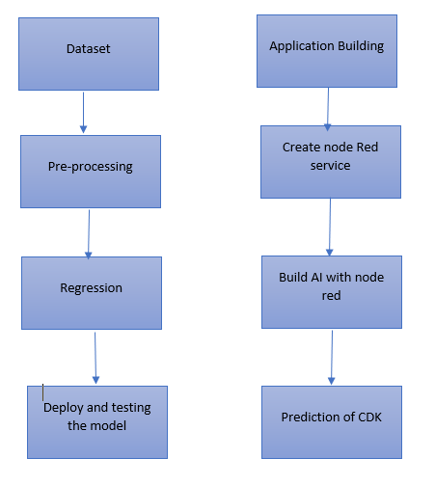

The project uses cloud object storage service ,machine learning service instance, Watson auto AI Experimental service.Experiment implements different pipelines and we use one pipeline which is best.Node red service is easily predict the value.

**Hardware/Software:**

This project is implemented using IBM cloud Services on watson studio,machine learining and cloud object storage service.

**EXPERIMENTL INVESGATION:**

Experimental Invesgation of general project consists of 6 steps:

1. Choose the idea of the project
2. Conduct a background research
3. Compose hypothesis
4. Design your own experiment
5. Collect the data
6. Analyse your data and draw conclusion

**FLOW CHART:**

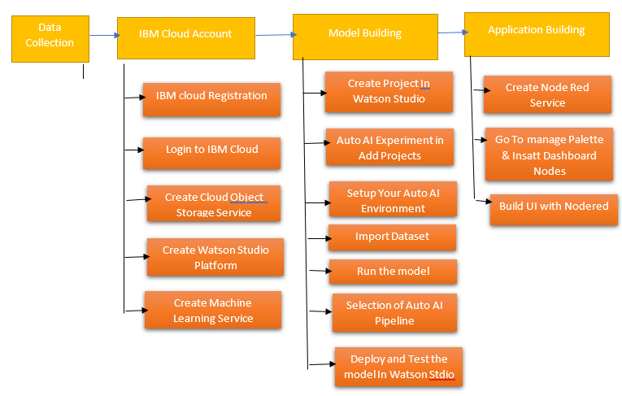

**RESULT:**

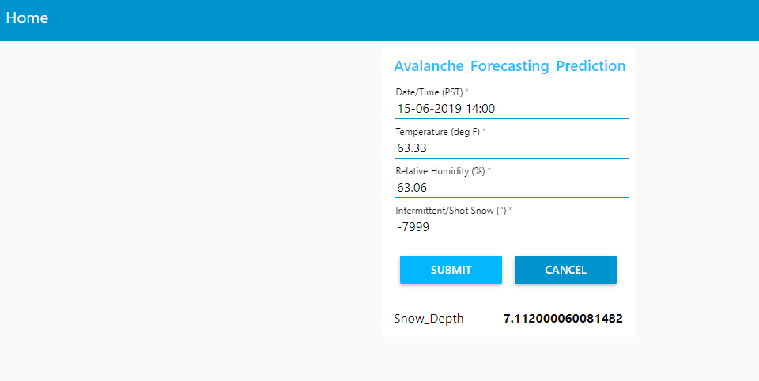

**APPLICATION:**

Node Red Service: Node red service provide us a better user UI and deploy machine learning model and get predicited value.

Auto AI Experiment: Using auto AI experiment you can build and deploy a machine learning model.

**CONCLUSION:**

This project is done completely with IBM cloud service. Firstly, we collect the data then created the cloud object storage service, created the Watson Studio, created machine learning services in IBM cloud.Then created project in Watson platform and using Auto AI experiment we deploy and test the experiment.Finally in Node red service we predict the result.

In this way we predict the results.

**FUTURE SCOPE:**

Their is a lot of scope in future with machine learning we can resolve lot of disadvantages which we have currently.

**BIBILOGRAPHY:**

This project uses the services like

* IBM cloud
* Cloud object storage service
* Watson Studio Auto AI
* Machine Learning service
* Node Red

|  |  |  |
| --- | --- | --- |
|  |  |  |